Subject: Cloud Helpdesk for Administrator | Effectivity Date:
Issued by: MIS Department | Revised Date:
Approved by: | Last Board Review Date
OVERVIEW
Cloud Helpdesk is a free online IT Tool developed by spiceworks to help IT Administrators, IT Technicians, and System Developers to monitor, track, and attend to pending tasks at hand via online job ticketing application. This is a cloud-based application that doesn’t require server procurement, setup and maintenance will not be an issue. The IT Team can also do the tracking of tickets via Mobile application.
PROBLEM ENCOUNTER
MIS Team is currently having a hard time monitoring pending tasks, prioritizing requests and the bulk of end-user requests has not been managed properly. Also the end-user has no tracking activity with regards to their request status.
PURPOSE
This will allow the MIS department to be more organized, focused, efficient and effective. Cloud helpdesk helps the MIS Department to correspond with end-users and their IT Tickets. The user portal will be an easy way for end-users to submit their ticket concern and check the progress without having to ask the MIS Department. Generation of reports will be much easier for the MIS department.

CLOUD HELPDESK

MIS ADMINISTRATOR LOGIN and Administrator page
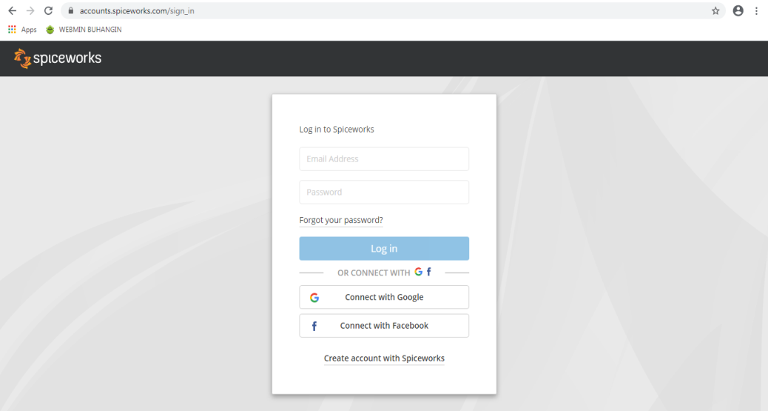
https://accounts.spiceworks.com/sign_in
GMAIL Account Credentials:
email: samulcomisteam@gmail.com
password: samulco2020

Spiceworks Account credentials:
email: samulcomisteam@gmail.com
password: Samulco2020

MIS TEAM LOGIN

MIS Administrator Page
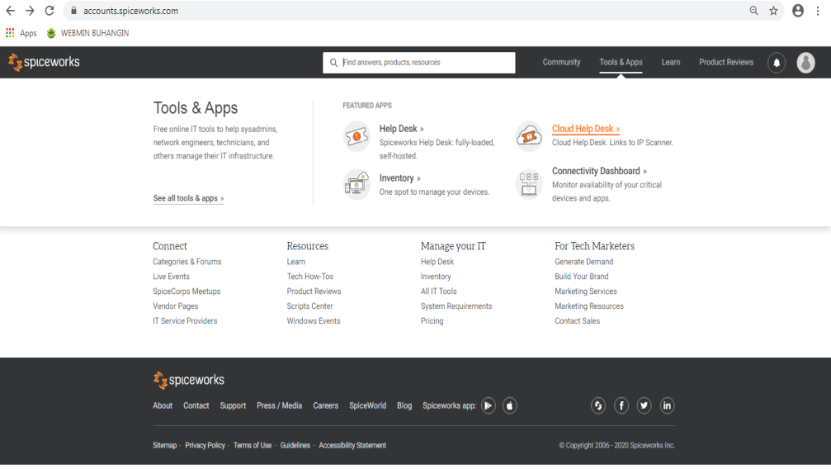
To proceed to dashboard,
hover your cursor to Tools & Apps
and click on Cloud Help Desk

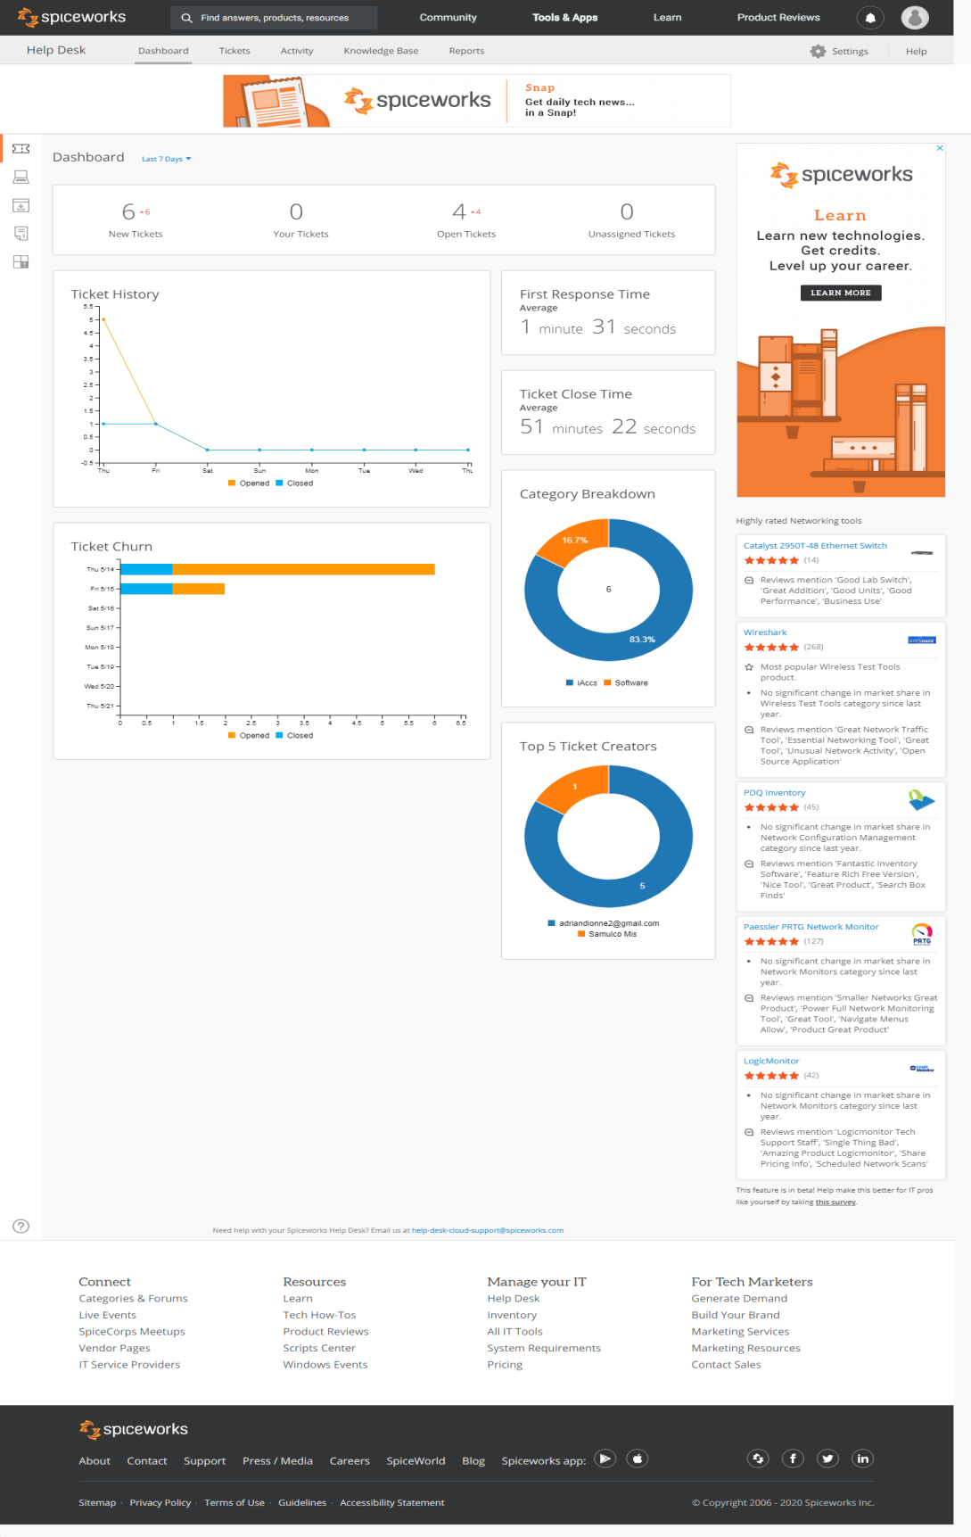
Over the dashboard, administrators
can oversee the statistics of tickets,
Average response time of all tickets,
most common problem category, and
the top ticket creators

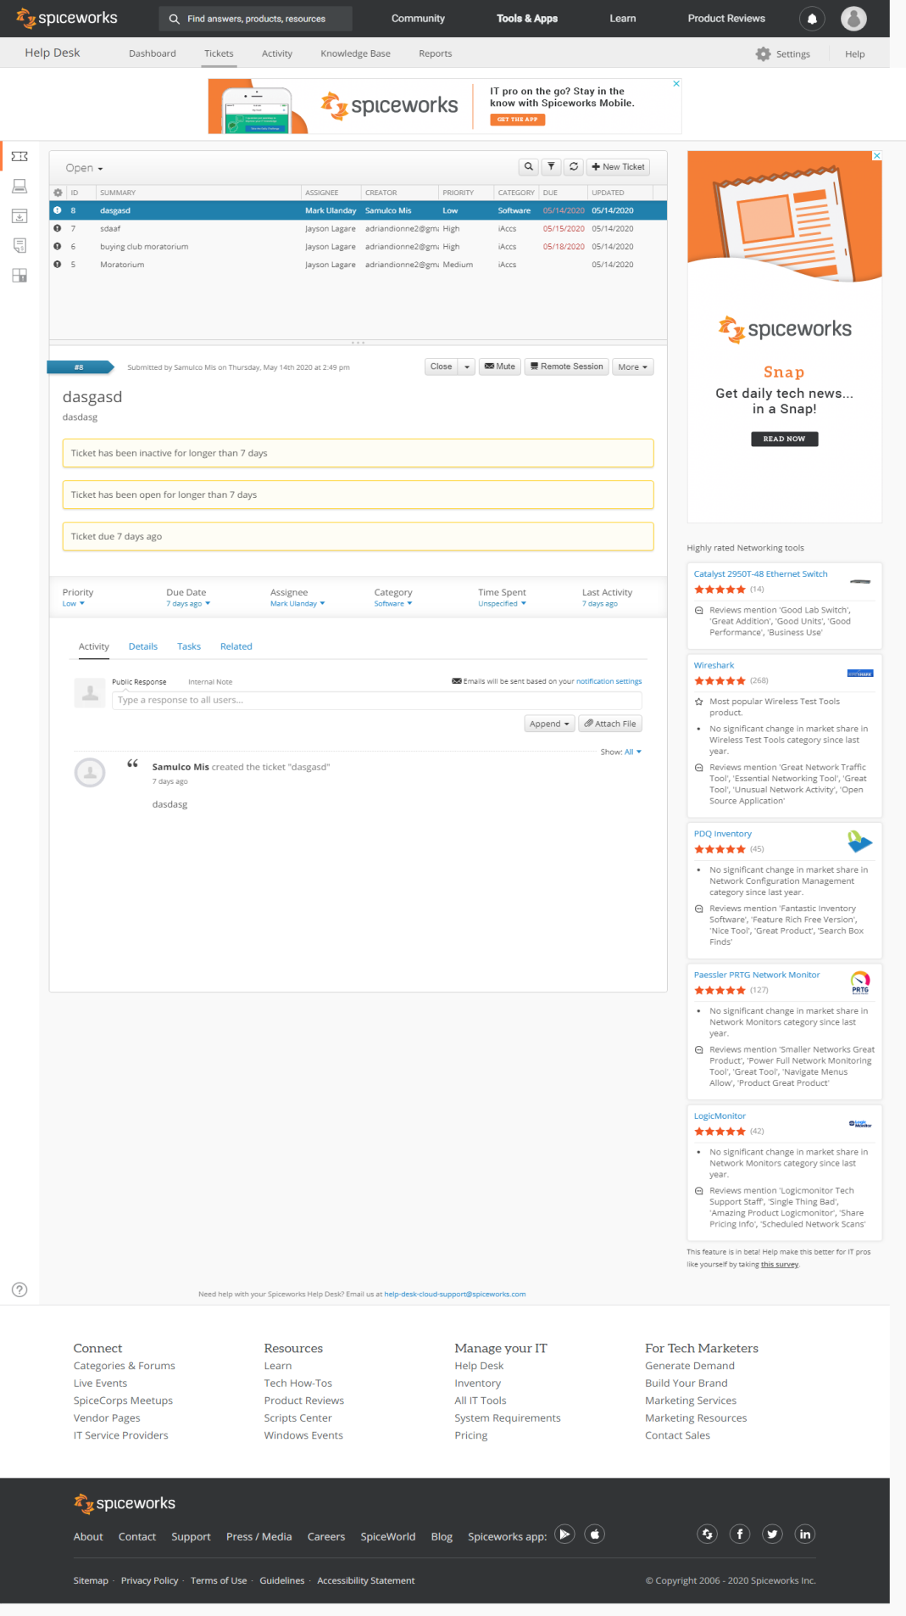
MIS Administrator Page
Ticket Interface
#1 List of tickets
#2 you can close/reopen tickets or
merge the ticket with other redundant
tickets
1
#3 you can define the tickets priority
level, due date and assign ticket to a
particular team member
2
#4 will serve as communication between
end-user with issue and the MIS Team.
Updates can be posted here and will be
directly send to the end-user registered email.
3

Note: #1 MIS administrators can also create
Internal tickets to be assigned to MIS team
Members
4

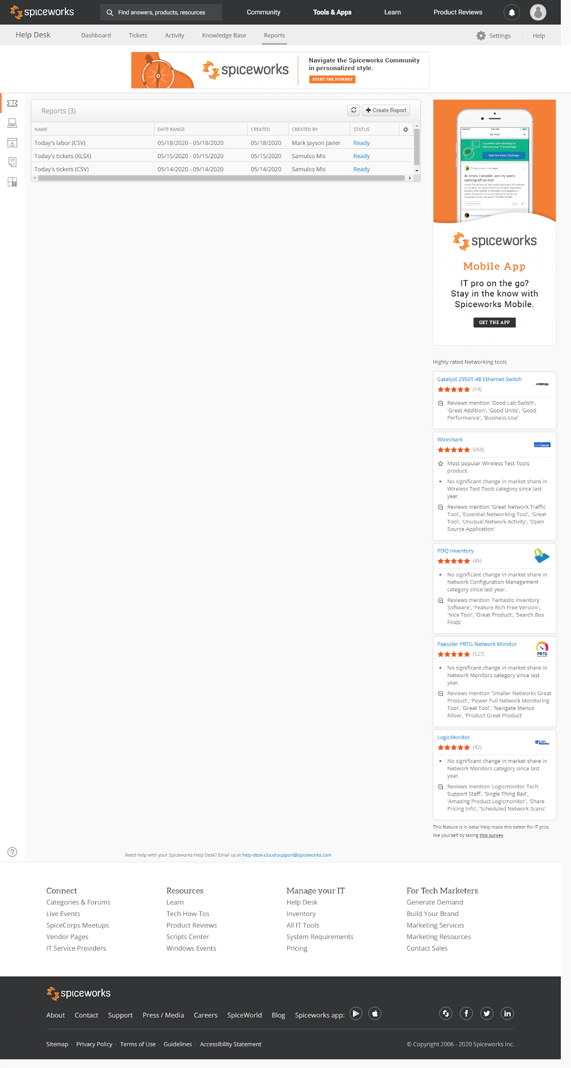
Report Interface
to generate a report, Click the
Create Report then filter the
date you want to generate.

MIS Administrator Page
Settings Page
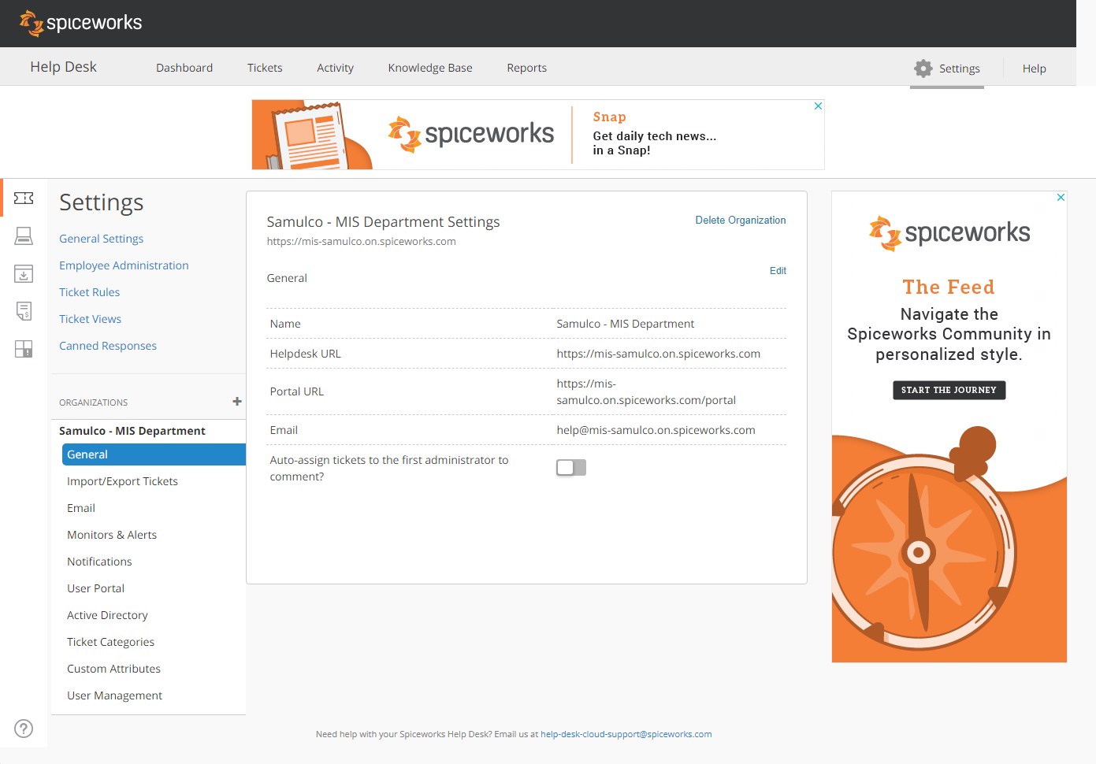
In this page, you can manage
User portal, manage team members
Ticket Rules, Ticket categories.

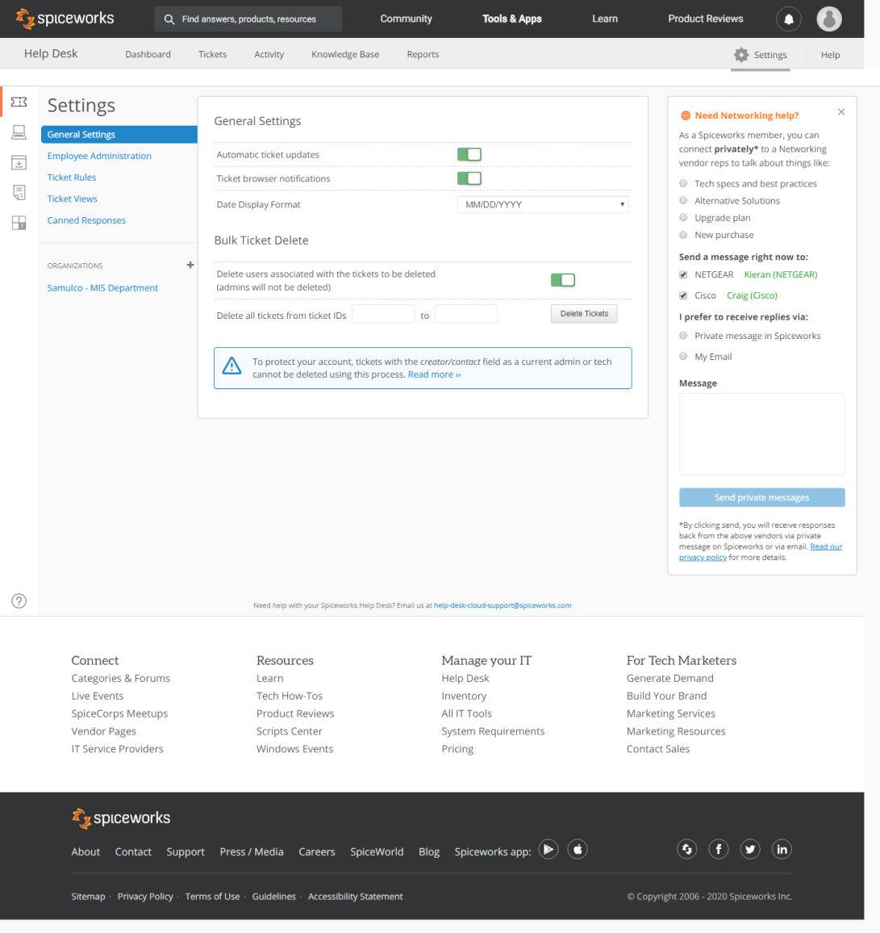
In the general settings you can set
automatic ticket updates, ticket
notifications.

MIS Administrator page
Settings page

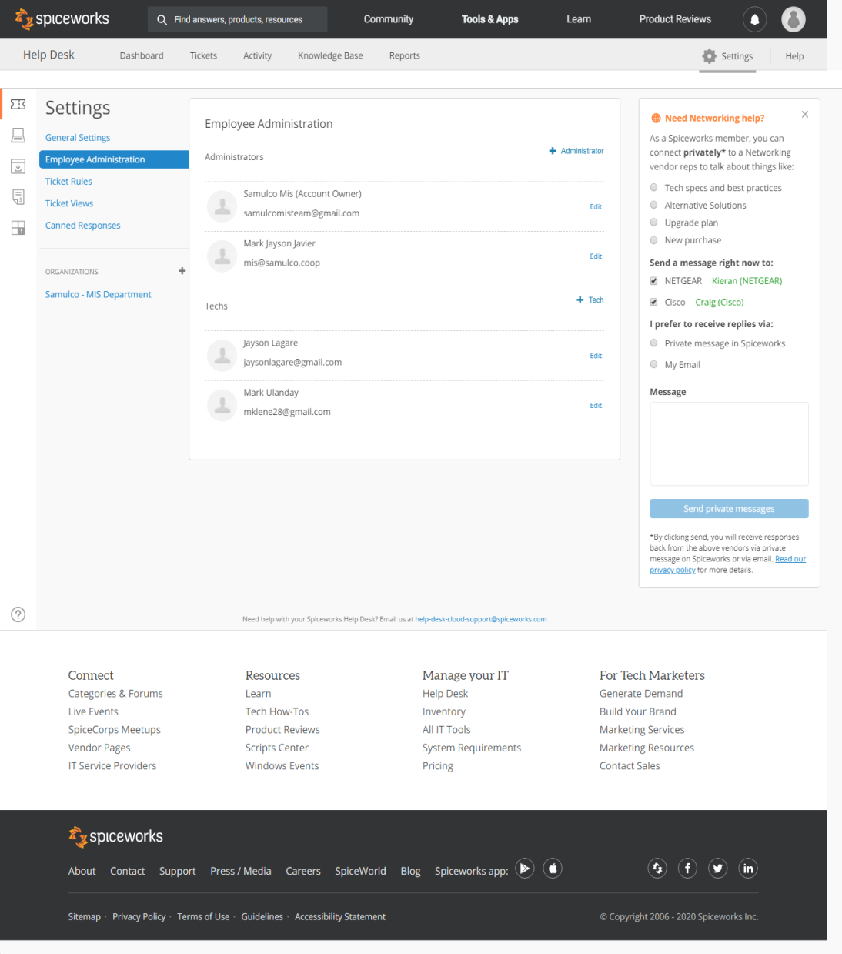
In the employee administration,
you can manage your team. You
can add new members and
define their functions.
Ticket Page settings
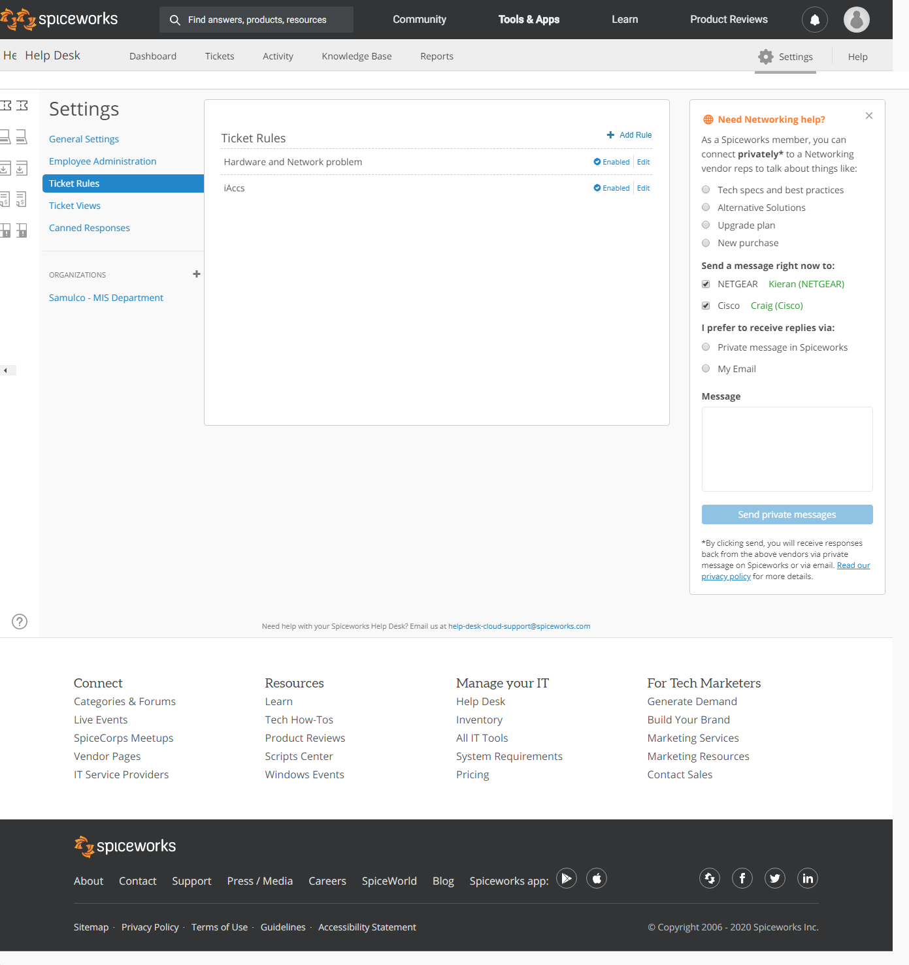

We can manage the tickets being
sent by end-user. We could set a
rule that a particular ticket will be
assign to a team member whose
designation and skills is fitted to
the concern.

MIS Administrator Page
Organization Page
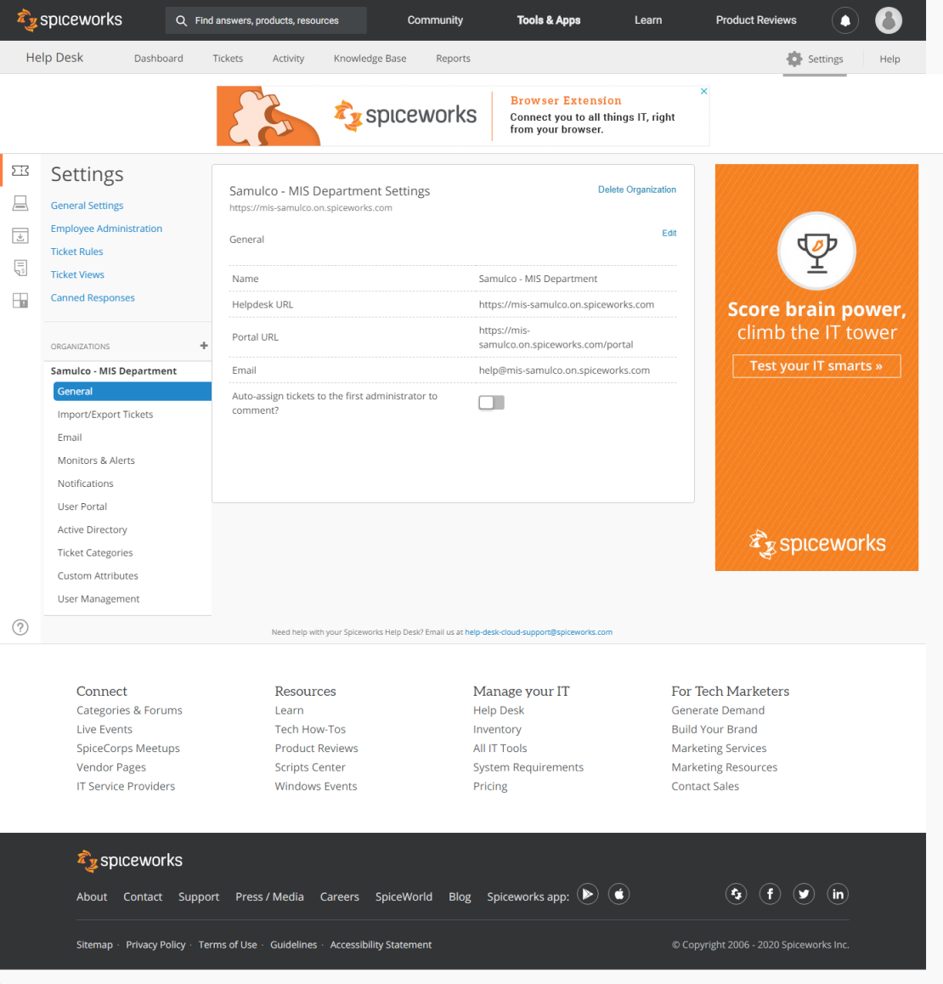
In this page, We can manage
the organizational settings,
such as our portal URL,
helpdesk URL, and email
address

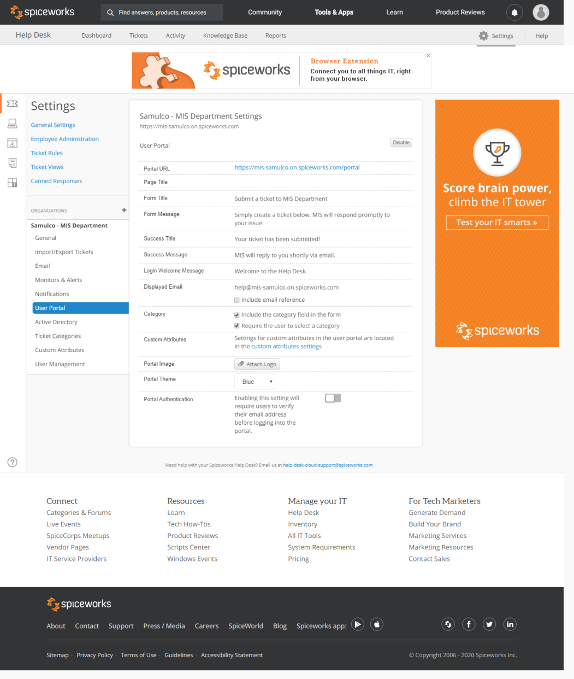
Portal Settings Page
In this page, we could customize
our portal page user interface

MIS Administrator Page
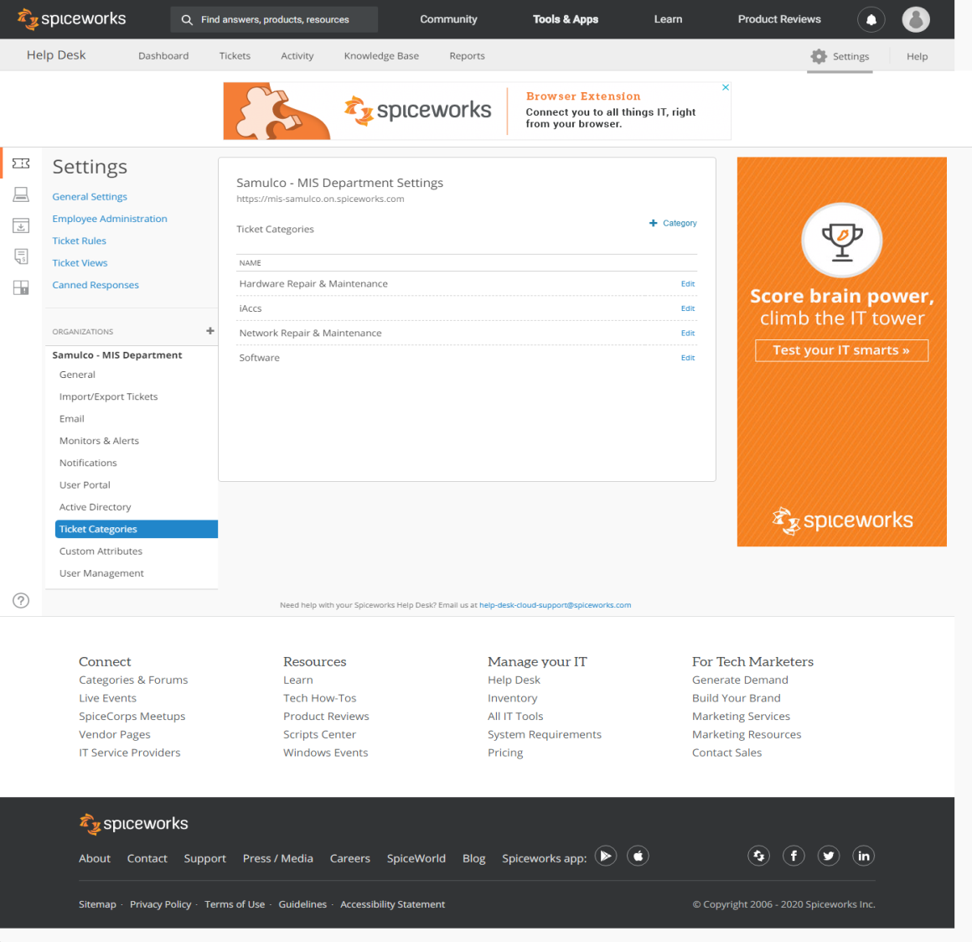
Ticket Categories Page
In this page, we could set
ticket categories which end-
user could select upon using
the portal page.
User portal page
https://mis-samulco.on.spiceworks.com/portal_registrations
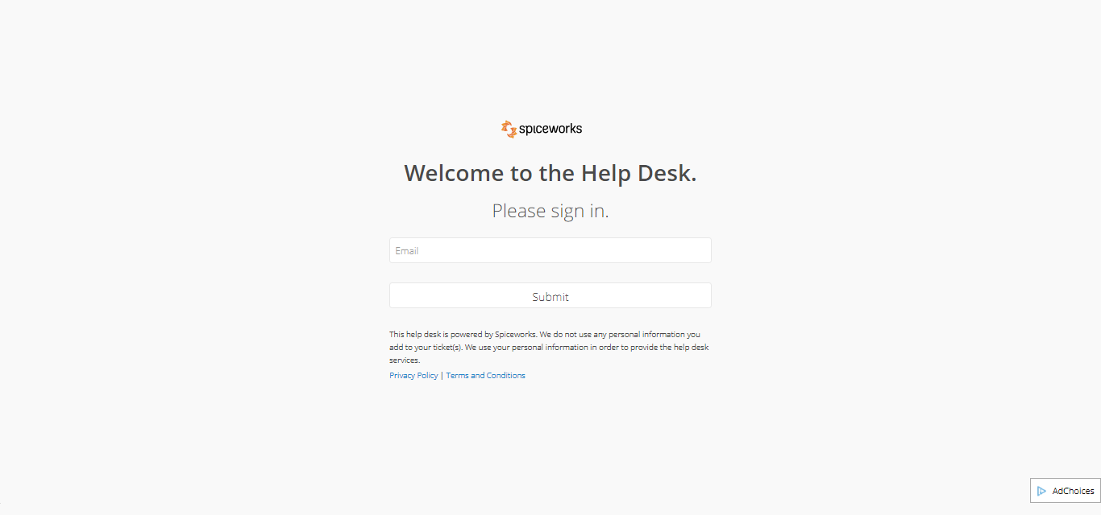
All users with concern must
login and register on portal
registration page. User must
provide a valid email address.
After registration, a link will
be sent to the email of the
requestor.

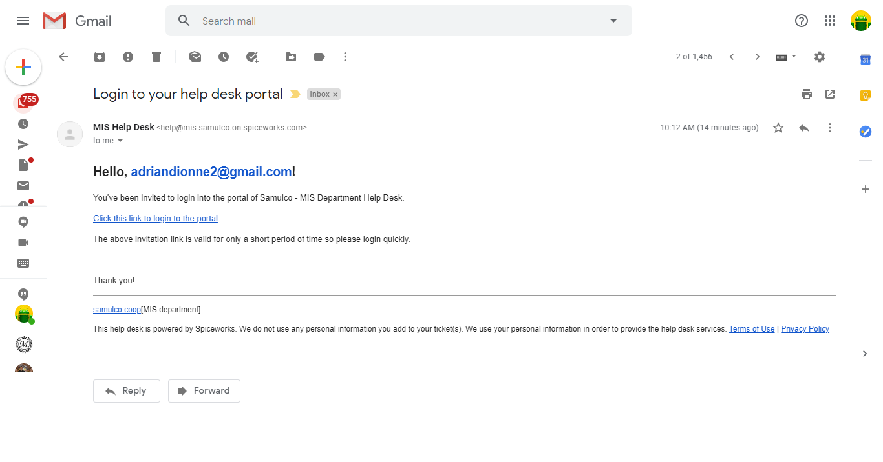
User Portal Page

Click on the highlighted link
to proceed to the portal

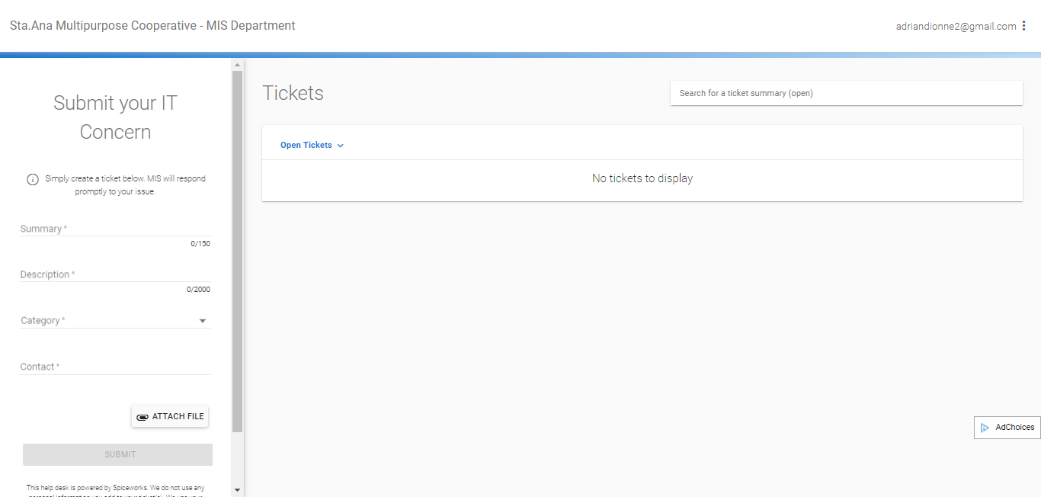
USER PORTAL
2
#1 Summary – Ticket title.
5
#2 Description - Brief description
of the problem.
1
#3 Category – end user will select
which category his/her problem
will fall into.
3
4
#4 Contact –requestor should
provide a contact number
#5 Requestor can see ticket updates,
and can do follow-up for overdue
tickets

